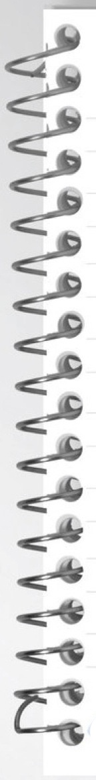

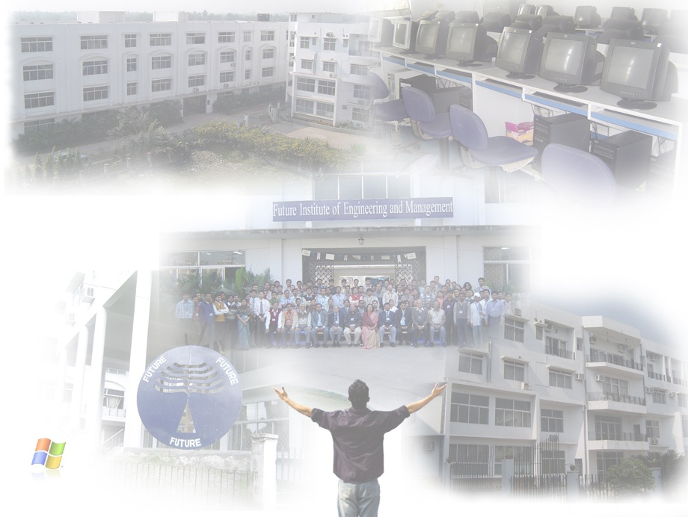

**IT Workshop Lab (Python) - PCC-CS393**

**REPORT ON:** …………………………..………………………………………………………………Lab.

**ROHAN CHATTOPADHYAY**

**NAME:** …………………………………………………………………………………………………………..

**COMPUTER SCIENCE & ENGINEERING**

**DEPARTMENT:** ……………………………………………………………………………………………..

**3RD**

**22/CSE/062**

**CSE-II**

**C**

**ROLL NO: .**……………..….…… **SEM:** …….…….… **GRP:** ….…… **SECTION:** ……..........

**1, 2, 3, 4**

**I**

**ASSIGNMENT NO:** ………..……**PROGRAM NO:** …..………………………………………....



**TITLE / OBJECTIVE:**

1. **Simple Interest  
   2. Celsius to Fahrenheit**

**3. Even number checker between a range**

**4. Area Calculation for Square, Rectangle and Circle**

.…………………………………………………..…………………………………..................................

……….………………………………………………………………………………..................................

………….……………………………………………………………………………..................................

………….……………………………………………………………………………..................................

………….……………………………………………………………………….…….................................



……….………………………………………………………………………………..................................

………….……………………………………………………………………………..................................

………….……………………………………………………………………………..................................



**28/07/2023**

**04/08/2023**

**PERFORMANCE DATE:** …....……………….. **SUBMISSION DATE:** ………………….......

**EXAMINER’S SIGNATURE:** ……………………………………………………………………………..